Isosceles Trapezoid

Definition
# Source: AI Source: Provided by: [Data Path: Persons Table -> ID Column: 1, Name_En Column: Motasem Essam] -> From: [ChatGPT] on [7/25/2026]
An isosceles trapezoid is a trapezoid in which the two non-parallel sides (legs) are congruent.
For trapezoid $ABCD$, if
$$AB∥CD$$
and
$$AD=BC$$
then $ABCD$is an isosceles trapezoid.
The parallel sides $AB$and $CD$are the bases, while $AD$and $BC$are the congruent legs.
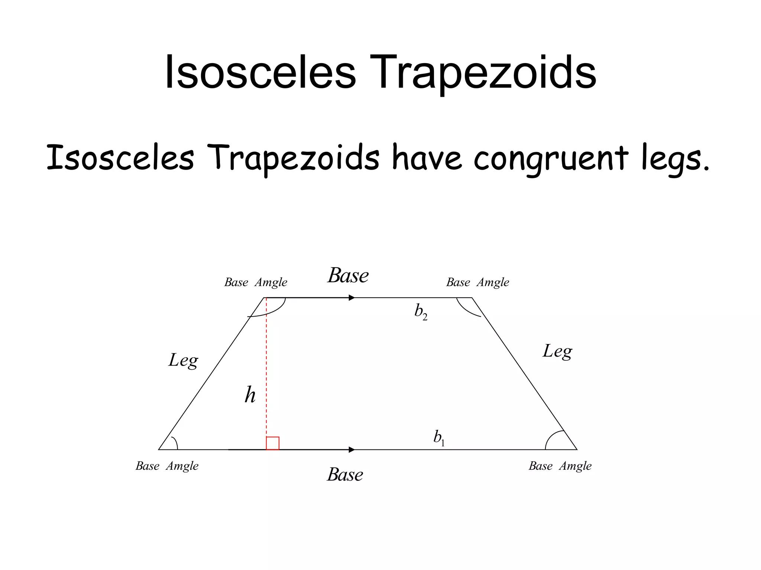
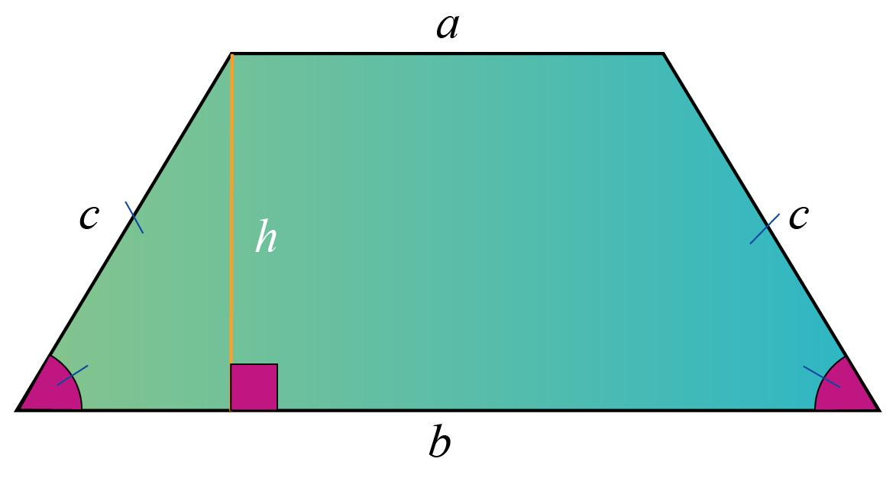
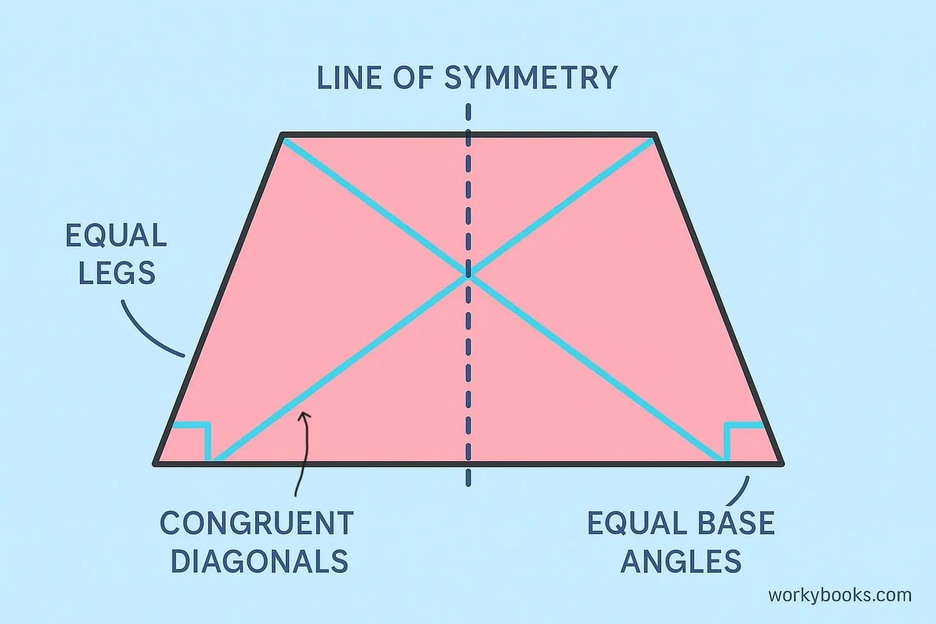
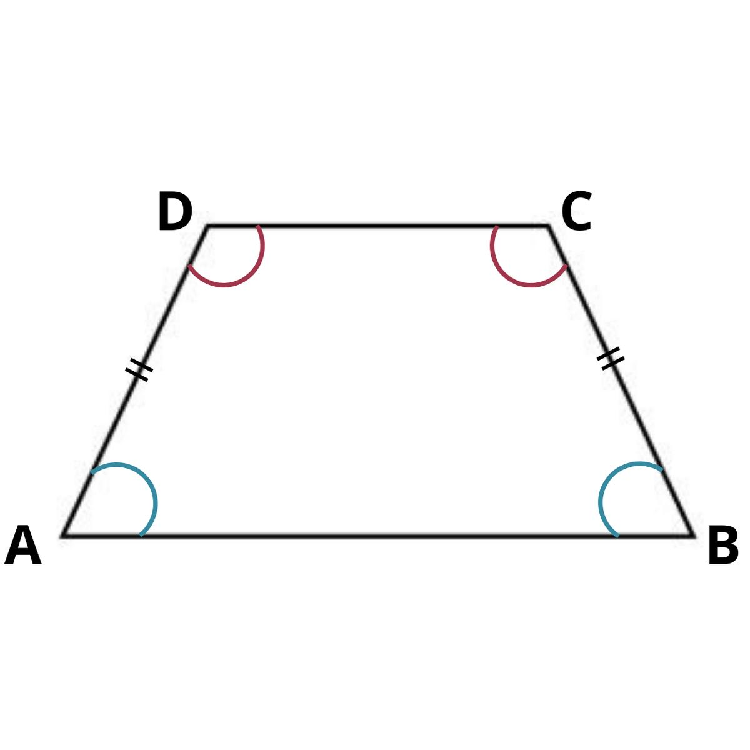
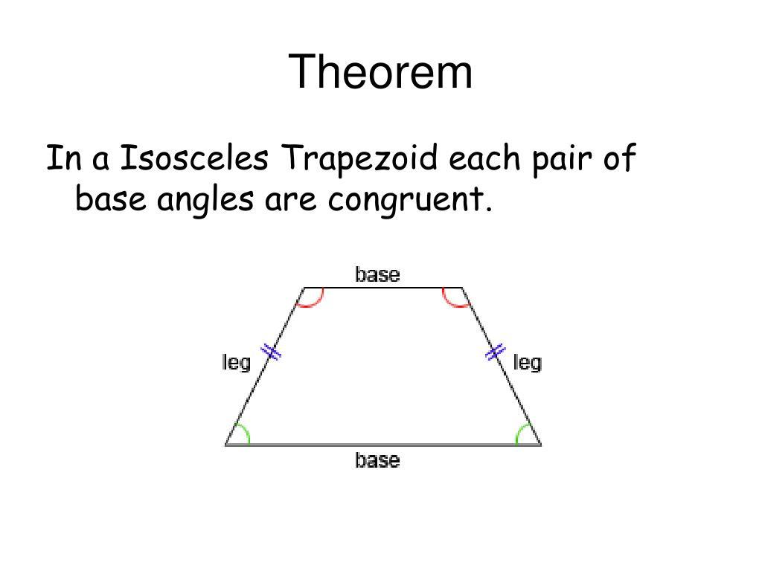

Purpose
# Source: AI Source: Provided by: [Data Path: Persons Table -> ID Column: 1, Name_En Column: Motasem Essam] -> From: [ChatGPT] on [7/25/2026]
An isosceles trapezoid is useful for:
- Studying symmetry in trapezoids.
- Understanding relationships between congruent sides and angles.
- Calculating area, perimeter, and diagonals.
- Applying congruence and parallel-line theorems.
- Solving geometric problems involving equal angles and equal lengths.

Fundamental Elements
Consider isosceles trapezoid $ABCD$, where
$$AB∥CD$$
and
$$AD=BC.$$

1. Bases
# Source: AI Source: Provided by: [Data Path: Persons Table -> ID Column: 1, Name_En Column: Motasem Essam] -> From: [ChatGPT] on [7/25/2026]
The parallel sides are:
$$\overset{‾}{AB}, \overset{‾}{CD}$$

2. Legs
# Source: AI Source: Provided by: [Data Path: Persons Table -> ID Column: 1, Name_En Column: Motasem Essam] -> From: [ChatGPT] on [7/25/2026]
The non-parallel sides are:
$$\overset{‾}{AD}, \overset{‾}{BC}$$
Because it is isosceles,
$$\boxed{AD=BC}$$

3. Vertices
# Source: AI Source: Provided by: [Data Path: Persons Table -> ID Column: 1, Name_En Column: Motasem Essam] -> From: [ChatGPT] on [7/25/2026]
$$A, B, C, D$$

4. Height
# Source: AI Source: Provided by: [Data Path: Persons Table -> ID Column: 1, Name_En Column: Motasem Essam] -> From: [ChatGPT] on [7/25/2026]
The height $h$is the perpendicular distance between the two bases.

5. Diagonals
# Source: AI Source: Provided by: [Data Path: Persons Table -> ID Column: 1, Name_En Column: Motasem Essam] -> From: [ChatGPT] on [7/25/2026]
The diagonals are:
$$\overset{‾}{AC}, \overset{‾}{BD}$$
In an isosceles trapezoid, the diagonals are congruent:
$$\boxed{AC=BD}$$
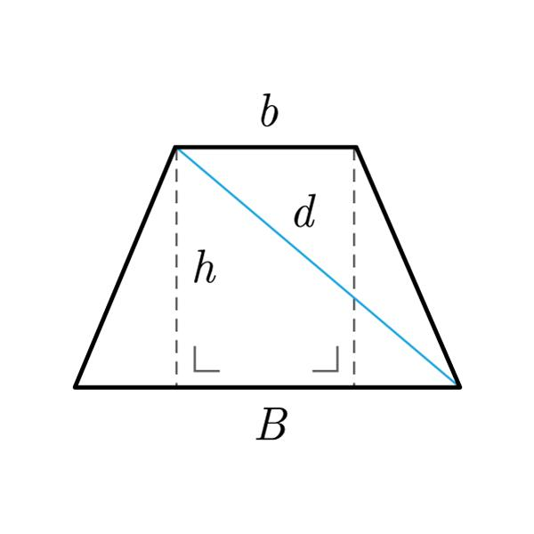
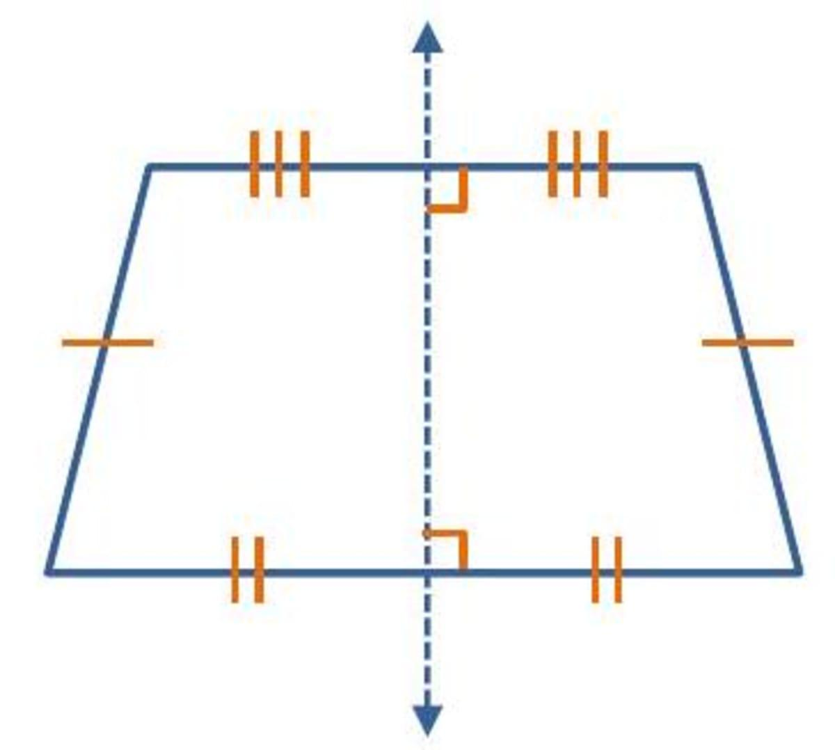
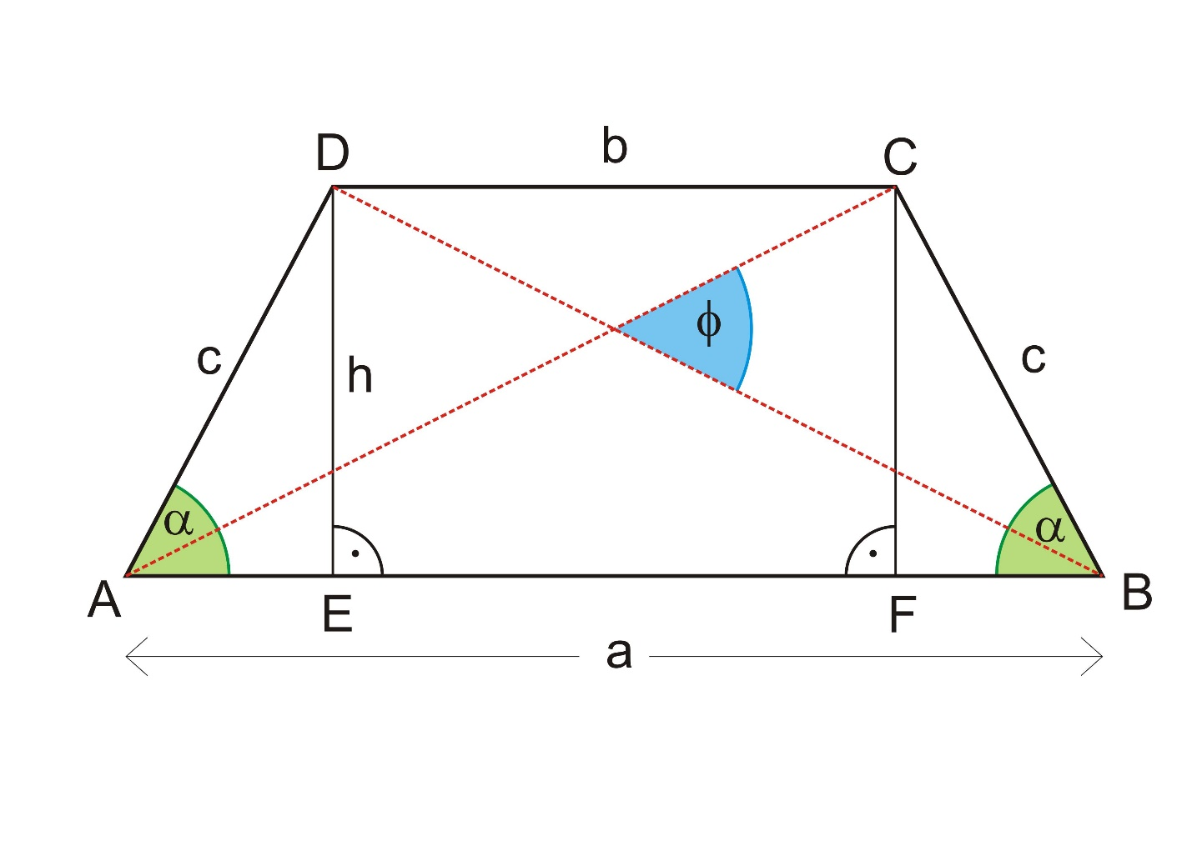

Main Properties
# Source: AI Source: Provided by: [Data Path: Persons Table -> ID Column: 1, Name_En Column: Motasem Essam] -> From: [ChatGPT] on [7/25/2026]
1. Congruent Legs
The defining property is
$$\boxed{AD=BC}$$
The two legs have equal lengths.

2. Congruent Base Angles
The angles adjacent to the same base are congruent.
Therefore,
$$\boxed{∠A=∠B}$$
and
$$\boxed{∠D=∠C}$$
This is one of the most important properties of an isosceles trapezoid.

3. Supplementary Consecutive Angles
Because the bases are parallel,
$$∠A+∠D={180}^{∘}$$
and
$$∠B+∠C={180}^{∘}.$$
Since the base angles are congruent, we also have
$$∠A=∠B$$
and
$$∠D=∠C.$$

4. Congruent Diagonals
The diagonals of an isosceles trapezoid are congruent:
$$\boxed{AC=BD}$$
This property does not generally hold for an ordinary trapezoid.

5. Line Symmetry
A non-parallelogram isosceles trapezoid has one line of symmetry.
The symmetry axis is perpendicular to the two bases and passes through their midpoints.
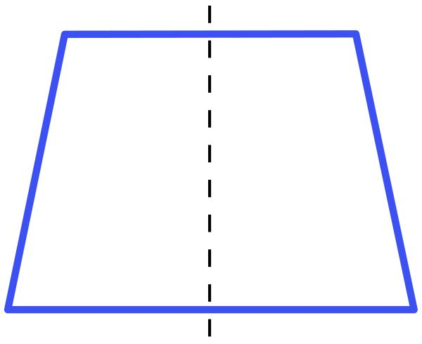
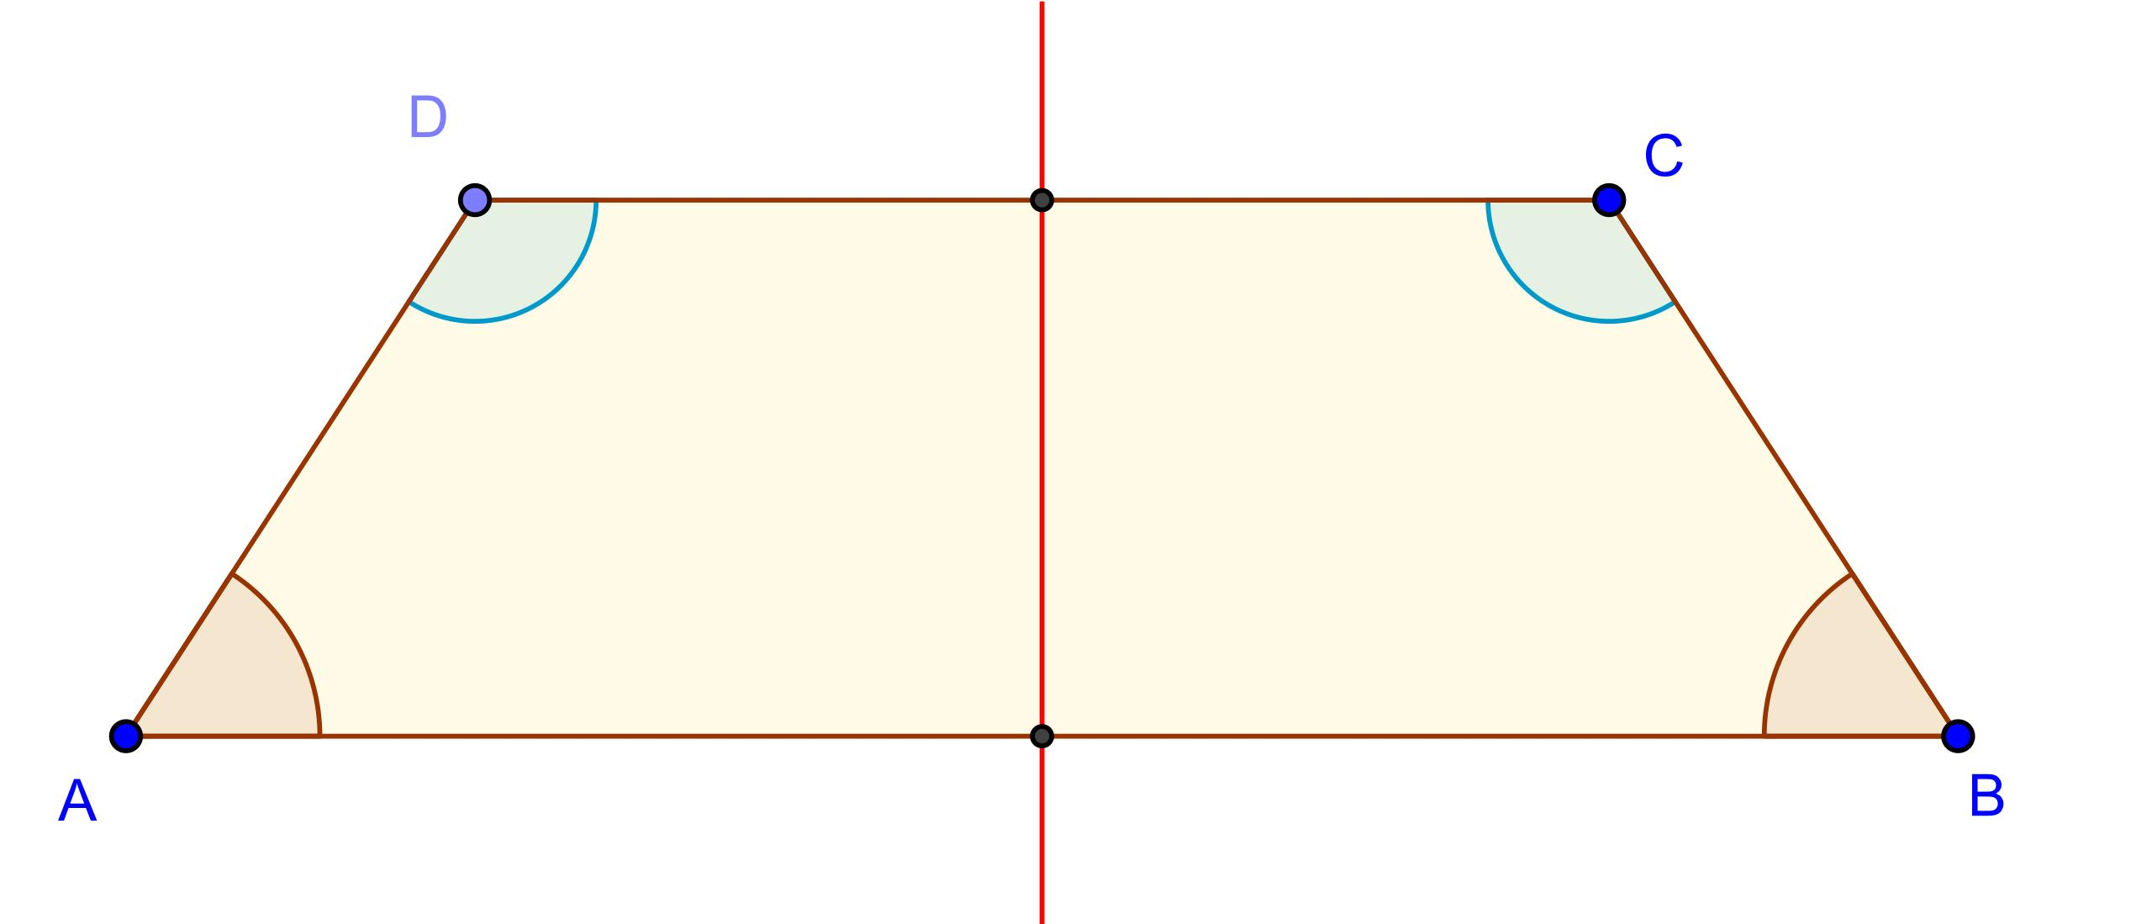
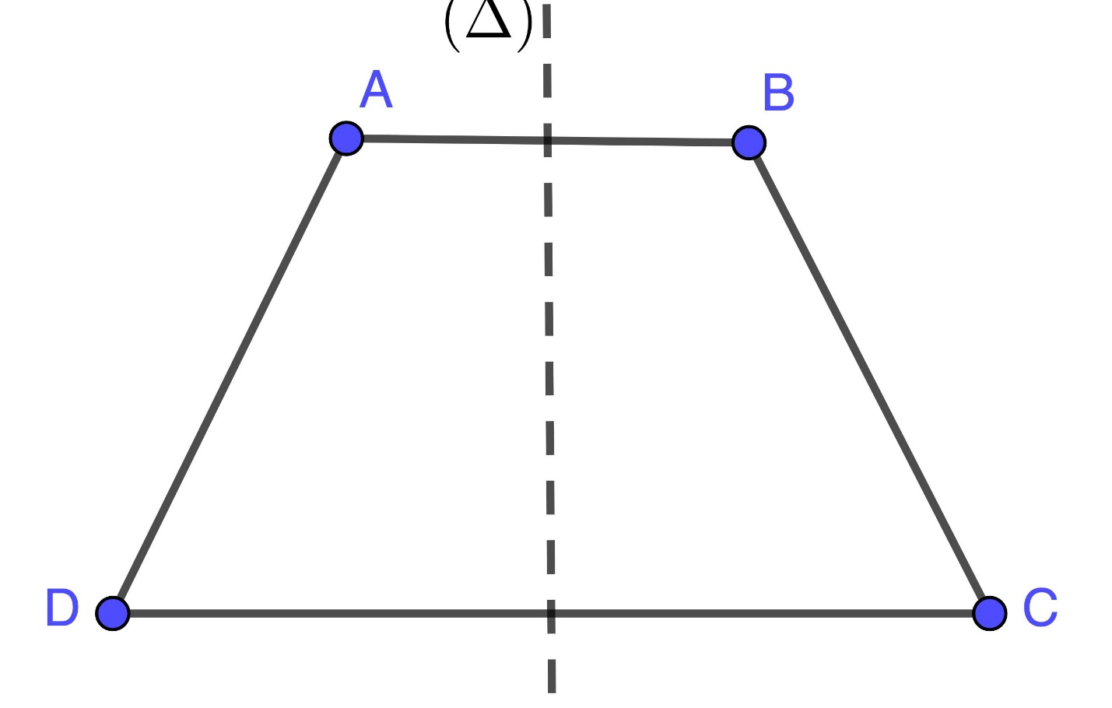

6. No Rotational Symmetry
A typical isosceles trapezoid does not have non-trivial rotational symmetry.
Rotating it by ${180}^{∘}$does not generally produce the same figure.

Mathematical Representation
# Source: AI Source: Provided by: [Data Path: Persons Table -> ID Column: 1, Name_En Column: Motasem Essam] -> From: [ChatGPT] on [7/25/2026]
Let:
- $a$= length of the first base
- $b$= length of the second base
- $l$= length of each leg
- $h$= height
Then
$$AD=BC=l.$$

Area
# Source: AI Source: Provided by: [Data Path: Persons Table -> ID Column: 1, Name_En Column: Motasem Essam] -> From: [ChatGPT] on [7/25/2026]
The area is
$$\boxed{A=\frac{\left(a+b\right)h}{2}}$$
or
$$A=\left(\frac{a+b}{2}\right)h.$$

Perimeter
# Source: AI Source: Provided by: [Data Path: Persons Table -> ID Column: 1, Name_En Column: Motasem Essam] -> From: [ChatGPT] on [7/25/2026]
Since the legs are equal,
$$P=a+b+l+l$$
so
$$\boxed{P=a+b+2l}$$

Height and Leg Relationship
# Source: AI Source: Provided by: [Data Path: Persons Table -> ID Column: 1, Name_En Column: Motasem Essam] -> From: [ChatGPT] on [7/25/2026]
For an isosceles trapezoid, dropping perpendiculars from the shorter base to the longer base creates two congruent right triangles.
If the longer base has length $b$, the shorter base has length $a$, and each leg has length $l$, then the horizontal segment of each right triangle is
$$\frac{b-a}{2}.$$
Using the Pythagorean theorem:
$$l^{2}=h^{2}+{\left(\frac{b-a}{2}\right)}^{2}$$
Therefore,
$$\boxed{h=\sqrt{l^{2}-{\left(\frac{b-a}{2}\right)}^{2}}}$$
This formula is useful when the height is not directly given.

Example 1 — Area
# Source: AI Source: Provided by: [Data Path: Persons Table -> ID Column: 1, Name_En Column: Motasem Essam] -> From: [ChatGPT] on [7/25/2026]
An isosceles trapezoid has bases
$$a=10\text{ cm}$$
and
$$b=18\text{ cm}$$
and height
$$h=6\text{ cm}.$$
Then
$$A=\frac{\left(a+b\right)h}{2} \\ A=\frac{\left(10+18\right)\left(6\right)}{2} \\ A=\frac{28×6}{2} \\ \boxed{A=84{\text{ cm}}^{2}}$$

Example 2 — Perimeter
# Source: AI Source: Provided by: [Data Path: Persons Table -> ID Column: 1, Name_En Column: Motasem Essam] -> From: [ChatGPT] on [7/25/2026]
Suppose the bases are
$$10\text{ cm}, 18\text{ cm}$$
and each leg is
$$7\text{ cm}.$$
Then
$$P=a+b+2l \\ P=10+18+2\left(7\right) \\ P=42$$
Therefore,
$$\boxed{P=42\text{ cm}}$$

Example 3 — Congruent Angles
# Source: AI Source: Provided by: [Data Path: Persons Table -> ID Column: 1, Name_En Column: Motasem Essam] -> From: [ChatGPT] on [7/25/2026]
Suppose
$$∠A={65}^{∘}.$$
Because the trapezoid is isosceles,
$$∠A=∠B.$$
Therefore,
$$\boxed{∠B={65}^{∘}}$$
Since consecutive angles along a leg are supplementary,
$$∠A+∠D={180}^{∘}.$$
Thus,
$${65}^{∘}+∠D={180}^{∘} \\ \boxed{∠D={115}^{∘}}$$
and because
$$∠D=∠C,$$
we get
$$\boxed{∠C={115}^{∘}}.$$
So the four angles are
$${65}^{∘}, {65}^{∘}, {115}^{∘}, {115}^{∘}.$$

Example 4 — Finding the Height
# Source: AI Source: Provided by: [Data Path: Persons Table -> ID Column: 1, Name_En Column: Motasem Essam] -> From: [ChatGPT] on [7/25/2026]
Suppose an isosceles trapezoid has:
$$b=20\text{ cm} \\ a=12\text{ cm}$$
and each leg is
$$l=5\text{ cm}.$$
Then
$$\frac{b-a}{2}=\frac{20-12}{2}=4\text{ cm}.$$
Using the Pythagorean theorem,
$$h^{2}+4^{2}=5^{2} \\ h^{2}+16=25 \\ h^{2}=9 \\ \boxed{h=3\text{ cm}}$$

Isosceles Trapezoid Theorem
# Source: AI Source: Provided by: [Data Path: Persons Table -> ID Column: 1, Name_En Column: Motasem Essam] -> From: [ChatGPT] on [7/25/2026]
A fundamental theorem states:
If a trapezoid has congruent legs, then its base angles are congruent.
For $ABCD$,
$$AB∥CD$$
and
$$AD=BC$$
imply
$$\boxed{∠A=∠B}$$
and
$$\boxed{∠D=∠C}.$$

Converse Properties
# Source: AI Source: Provided by: [Data Path: Persons Table -> ID Column: 1, Name_En Column: Motasem Essam] -> From: [ChatGPT] on [7/25/2026]
There are also useful converse relationships.
If a trapezoid has congruent base angles, then it is an isosceles trapezoid.
For example,
$$∠A=∠B$$
together with
$$AB∥CD$$
implies that the legs are congruent:
$$\boxed{AD=BC}.$$
Similarly, congruent diagonals characterize an isosceles trapezoid under the usual trapezoid assumptions:
$$AC=BD$$
implies the trapezoid is isosceles.

Midsegment
# Source: AI Source: Provided by: [Data Path: Persons Table -> ID Column: 1, Name_En Column: Motasem Essam] -> From: [ChatGPT] on [7/25/2026]
The midsegment connects the midpoints of the two legs.
It is parallel to both bases.
If the bases have lengths $a$and $b$, then
$$\boxed{m=\frac{a+b}{2}}$$
The area can therefore be written as
$$\boxed{A=mh}.$$
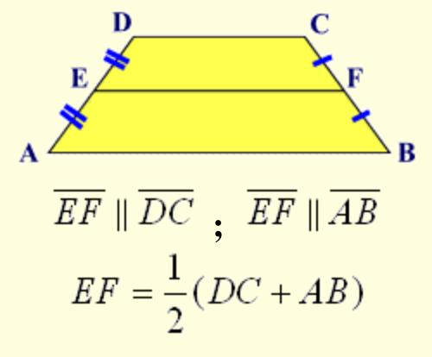
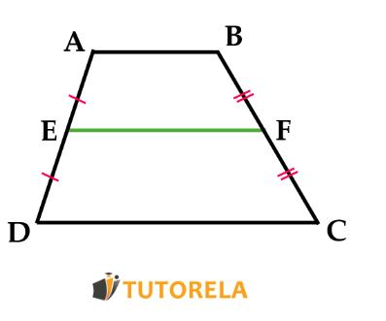
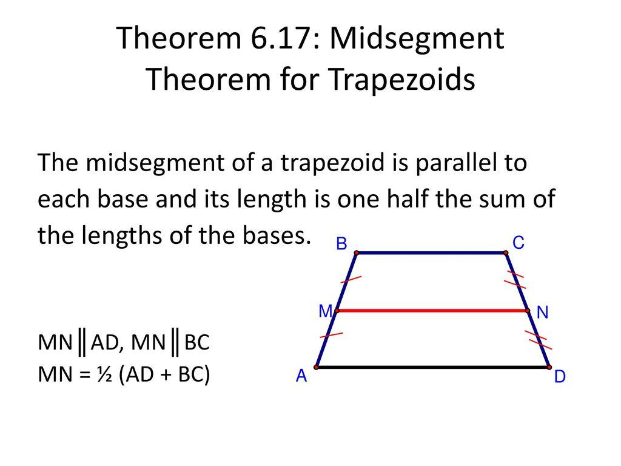
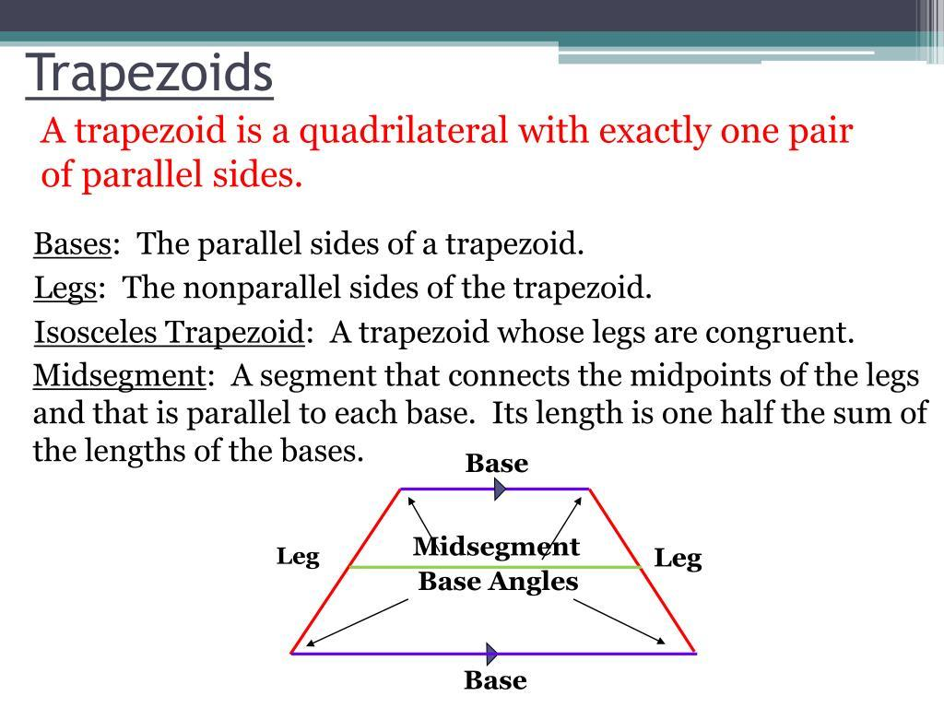

Relationship with Other Trapezoids
# Source: AI Source: Provided by: [Data Path: Persons Table -> ID Column: 1, Name_En Column: Motasem Essam] -> From: [ChatGPT] on [7/25/2026]
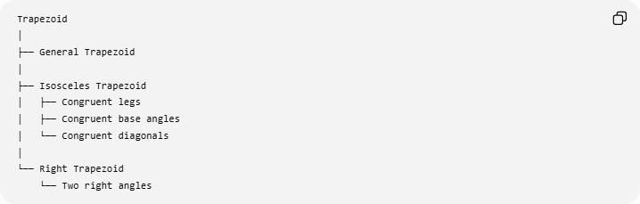
Trapezoid
│
├── General Trapezoid
│
├── Isosceles Trapezoid
│ ├── Congruent legs
│ ├── Congruent base angles
│ └── Congruent diagonals
│
└── Right Trapezoid
└── Two right angles
An isosceles trapezoid is distinguished primarily by
$$\boxed{\text{Congruent legs}}$$
rather than by right angles.

Comparison with a General Trapezoid
# Source: AI Source: Provided by: [Data Path: Persons Table -> ID Column: 1, Name_En Column: Motasem Essam] -> From: [ChatGPT] on [7/25/2026]
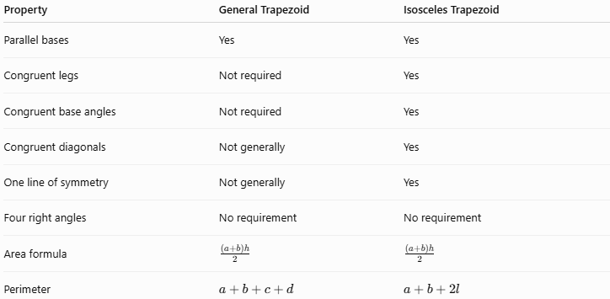
Property | General Trapezoid | Isosceles Trapezoid
Parallel bases | Yes | Yes
Congruent legs | Not required | Yes
Congruent base angles | Not required | Yes
Congruent diagonals | Not generally | Yes
One line of symmetry | Not generally | Yes
Four right angles | No requirement | No requirement
Area formula | $$\frac{\left(a+b\right)h}{2}$$ | $$\frac{\left(a+b\right)h}{2}$$
Perimeter | $$a+b+c+d$$ | $$a+b+2l$$

Comparison with Related Quadrilaterals
# Source: AI Source: Provided by: [Data Path: Persons Table -> ID Column: 1, Name_En Column: Motasem Essam] -> From: [ChatGPT] on [7/25/2026]
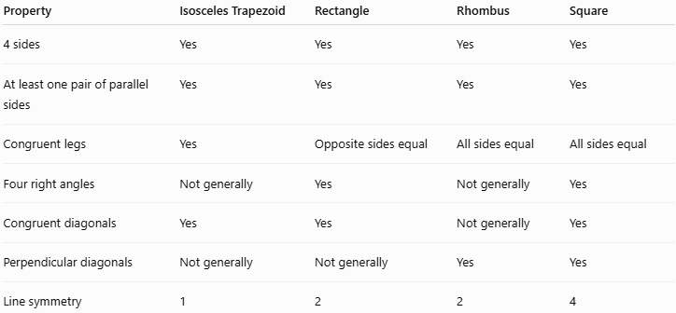
Property | Isosceles Trapezoid | Rectangle | Rhombus | Square
4 sides | Yes | Yes | Yes | Yes
At least one pair of parallel sides | Yes | Yes | Yes | Yes
Congruent legs | Yes | Opposite sides equal | All sides equal | All sides equal
Four right angles | Not generally | Yes | Not generally | Yes
Congruent diagonals | Yes | Yes | Not generally | Yes
Perpendicular diagonals | Not generally | Not generally | Yes | Yes
Line symmetry | 1 | 2 | 2 | 4

Real-World Applications
# Source: AI Source: Provided by: [Data Path: Persons Table -> ID Column: 1, Name_En Column: Motasem Essam] -> From: [ChatGPT] on [7/25/2026]
Isosceles trapezoids can be found in:
- Architectural structures
- Bridge designs
- Roof structures
- Lampshades
- Furniture
- Decorative patterns
- Engineering components
- Trapezoidal containers
- Symmetrical logos and designs

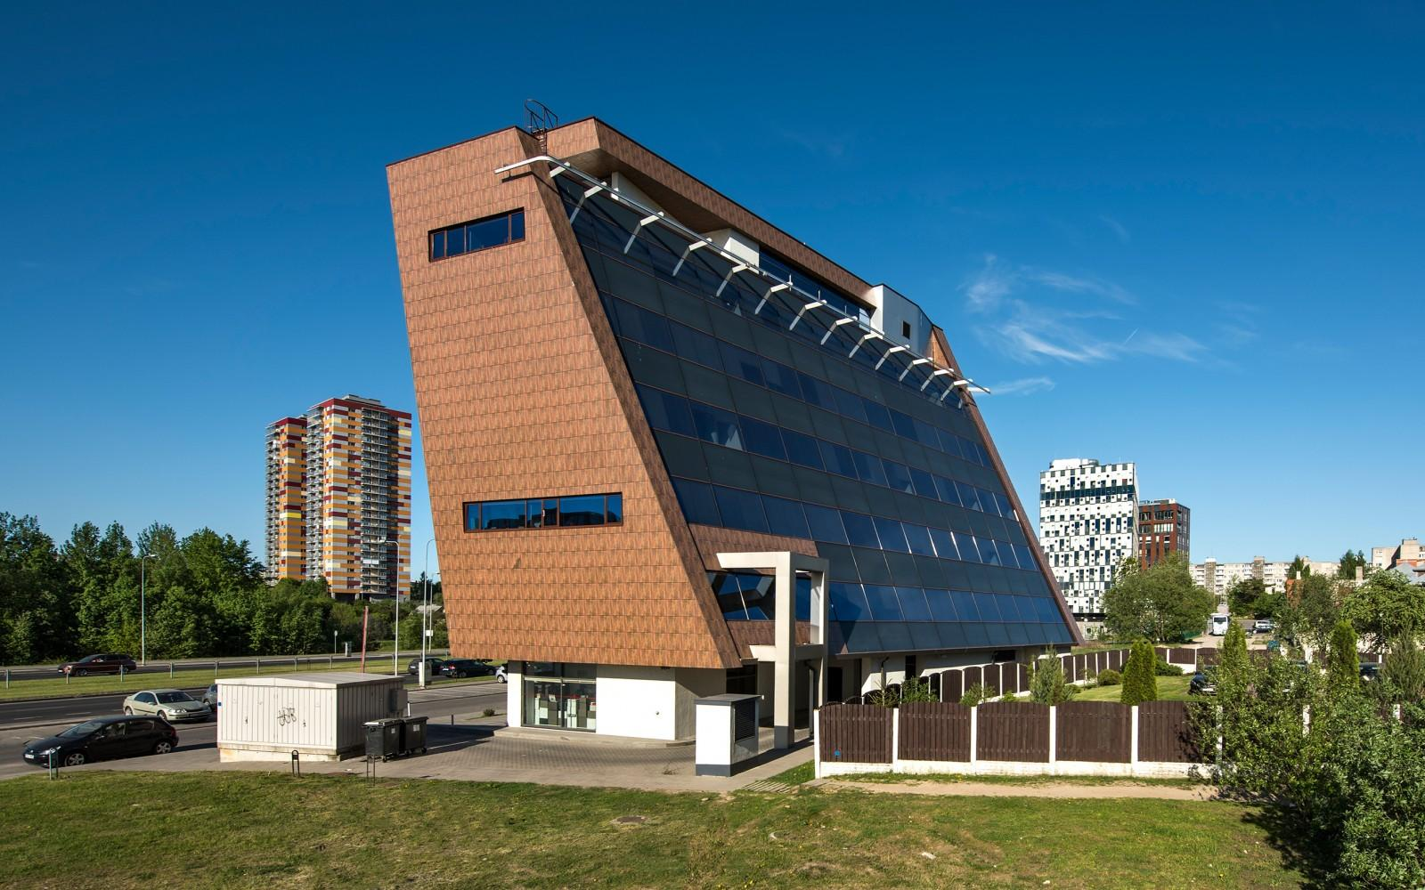
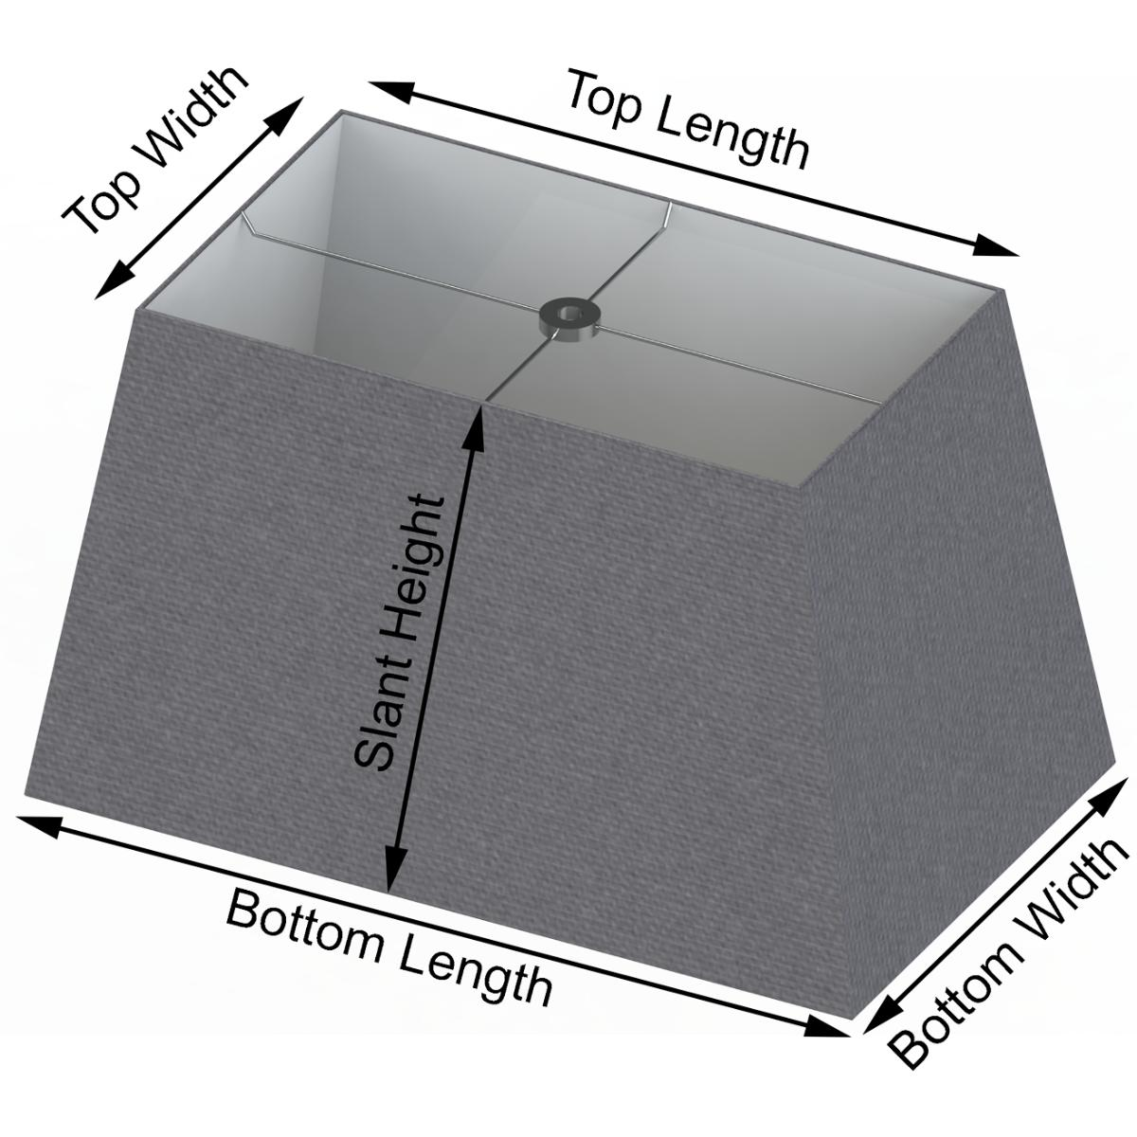

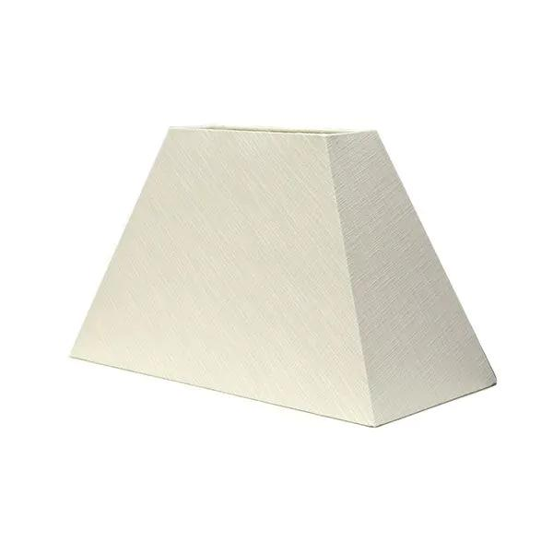

Advantages
# Source: AI Source: Provided by: [Data Path: Persons Table -> ID Column: 1, Name_En Column: Motasem Essam] -> From: [ChatGPT] on [7/25/2026]
- Has strong symmetry properties.
- Equal legs simplify calculations.
- Base angles are immediately related.
- Diagonals are congruent.
- Useful for constructing symmetrical designs.
- Area and perimeter formulas are straightforward.

Limitations
# Source: AI Source: Provided by: [Data Path: Persons Table -> ID Column: 1, Name_En Column: Motasem Essam] -> From: [ChatGPT] on [7/25/2026]
An isosceles trapezoid does not generally have:
- Four right angles.
- Perpendicular diagonals.
- Diagonals that bisect each other.
- Four congruent sides.
- Rotational symmetry.
These properties belong to other special quadrilaterals or special cases.

Key Points
# Source: AI Source: Provided by: [Data Path: Persons Table -> ID Column: 1, Name_En Column: Motasem Essam] -> From: [ChatGPT] on [7/25/2026]
- An isosceles trapezoid is a trapezoid with congruent legs.
- If $AB∥CD$, then
$$\boxed{AD=BC}$$
- Its base angles are congruent:
$$\boxed{∠A=∠B} \\ \boxed{∠C=∠D}$$
- Its diagonals are congruent:
$$\boxed{AC=BD}$$
- It has one line of symmetry.
- Its area is
$$\boxed{A=\frac{\left(a+b\right)h}{2}}$$
- Its perimeter is
$$\boxed{P=a+b+2l}$$
- Its midsegment is
$$\boxed{m=\frac{a+b}{2}}$$
- Consecutive angles along each leg are supplementary.
- It is more specialized than a general trapezoid.

Conclusion
# Source: AI Source: Provided by: [Data Path: Persons Table -> ID Column: 1, Name_En Column: Motasem Essam] -> From: [ChatGPT] on [7/25/2026]
An Isosceles Trapezoid is a special type of trapezoid characterized by two congruent legs. This condition produces several important consequences: the base angles are congruent, the diagonals are congruent, and the figure has one line of symmetry. These properties make the isosceles trapezoid especially useful in geometry, symmetry, construction, and engineering.
I can next organize Right Trapezoid in the same taxonomy so your three trapezoid types are complete and consistent.

